**Karan Arora** **R.L. Institute M: 9416974837**

**Max Time : 1 ½ hr** **Class : 10th Science Max Marks : 40**

**Acid Base & Salts , Heredity , Metal & Non-metal , Magnetic Effect**

1. Multiple choice Questions: [ 1 x 12 = 12p ]
2. Mild non-corrosive basic is :

|  |  |  |  |
| --- | --- | --- | --- |
| a) Ca(OH)2 | b) NaCl | c) NaOH | d) NaHCO3 |

1. Acid present in tomatoes is :

|  |  |  |  |
| --- | --- | --- | --- |
| a) Methanoic acid | b) Acetic acid | c) Lactic acid | d) Oxalic acid |

1. Sodium hydroxide is termed an alkali while Ferric hydroxide is not because:
2. Sodium hydroxide is a strong base, while Ferric hydroxide is a weak base.
3. Sodium hydroxide is a base which is soluble in water while Ferric hydroxide is also a base which is insoluble in water.
4. Sodium hydroxide is strong base while Ferric hydroxide is strong acid.
5. Sodium hydroxide and Ferric hydroxide both are strong base but the solubility of Sodium hydroxide in water is comparatively higher than that of Ferric hydroxide.
6. The name of the salt used to remove permanent hardness of water is:

|  |  |
| --- | --- |
| a) Sodium hydrogen carbonate (NaHCO3) | b) Sodium chloride (NaCl) |
| c) Sodium carbonate decahydrate (Na2CO3.10H2O) | d) Calcium sulphate hemihydrate (CaSO4.H2O) |

1. An alpha particle enters a uniform magnetic field as shown. The direction of force experienced by the alpha particle is :

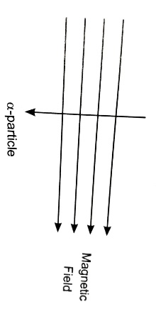

|  |  |  |  |
| --- | --- | --- | --- |
| a) towards right | b) towards left | c) into the page | d) out of the page |

1. Which of the following is a Gypsum?

|  |  |  |  |
| --- | --- | --- | --- |
| a) CaSO4.H2O | b) CaSO4. H2O | c) CaSO4. 2H2O | d) CaSO4. 3H2O |

1. Four test tubes, containing solutions, are shown along with colours. FeSO4 is contained in :

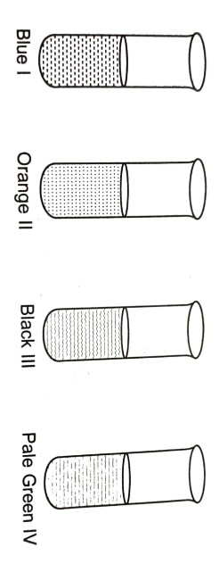

|  |  |  |  |
| --- | --- | --- | --- |
| a) II | b) IV | c) III | d) I |

1. Which of the following option correctly represents the parent acid and base of sodium sulphate?

|  |  |
| --- | --- |
| a) HCL and Na2SO4 | b) H2SO4 and NaCl |
| c) H2SO4 and NaOH | d) HCL and Na2CO3 |

1. By which instrument, the presence of magnetic field can be determined?

|  |  |  |  |
| --- | --- | --- | --- |
| a) Magnetic needle | b) Ammeter | c) Galvanometer | d) Voltmeter |

1. Observe the figure given by :

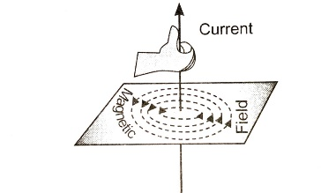

|  |  |
| --- | --- |
| a) Right-hand thumb rule | b) Maxwell’s left hand thumb rule |
| c) Maxwell’s corkscrew rule | d) Left hand thumb rule |

1. On a pH scale, pH of blood is shown below. What is the nature of blood?

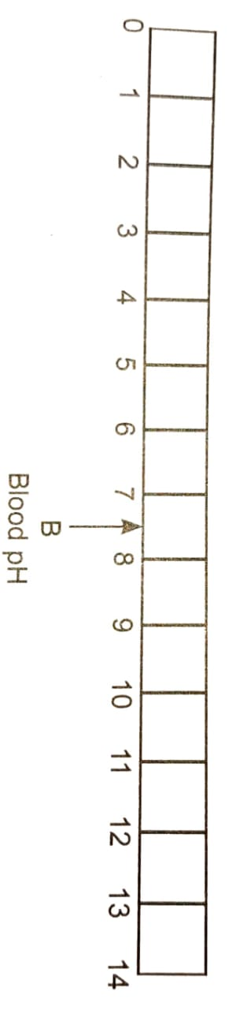

|  |  |  |  |
| --- | --- | --- | --- |
| a) slightly alkaline | b) Slightly acidic | c) Highly alkaline | d) Neutral |

1. The maleness of a child is determined by :

|  |  |
| --- | --- |
| a) The X chromosome in the zygote | b) The Y chromosome in the zygote |
| c) The cytoplasm of germ cell which determine sex | d) Sex is determined by chance |

**Section – B [ 1 X 6 = 6 ]**

1. Generally, non-metals are not lustrous. Name a non-metal which is lustrous.
2. In addition to sodium hydrogen carbonate, baking powder containing a substance ‘X’. Name the ‘X’.
3. Name the substance obtained by action of chlorine on dry slaked lime.
4. Where is DNA found in a cell?
5. Newly formed DNA copies may not be identical at times. Give one reason.

Or

Define Alleles.

1. Where does the closeness of field lines in a magnetic field signify?

**Section – C [ 2 X 5 = 10 ]**

1. What is law of dominance of traits?
2. Identify the acid and the base from which sodium chloride is obtained. Which type of salt is it? when is it called rock salt? How is rock salt formed?
3. List any three properties of magnetic field lines.
4. Why does Mendel choose pea plant for his experiment?

Or

Give the pair of contrasting traits of the following characters in pea plant and mention which is dominant and recessive:

(a) Yellow seed (b) Round seed

1. Explain the formation of Acidic , Basic and neutral salts.

**Section – D [ 3 X 4 = 12 ]**

1. (i) Suggest a safe procedure of diluting a strong concentrated acid.

(ii) Name the salt formed when sulphuric acid is added to sodium hydroxide and write its pH.

(iii) Dry HCl gas does not change the colour of dry blue litmus paper. Why?

1. What are permanent magnet and electro magnet? Give two uses of each.
2. If we cross-breed tall (dominant) pea plant with pure-breed dwarf (recessive) pea plant, we will get plant of F1 generation. If we now self-cross the pea plant of F1 generation, we obtain pea plants of F2 generation.
   1. What name is given to such type of cross.
   2. Make a flow diagram cross between the parents showing F1 and F2 generation.
   3. Write the genotype of (i) parents (ii) F2 generation.
3. Write the chemical formula of washing soda. How can it be obtained from baking soda? List two industries in which washing soda is used for other purposes than washing clothes.

Or

Answer the following question on the basis of diagram given below:

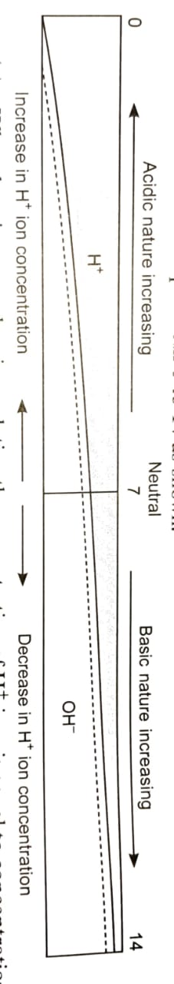

1. What does it mean when in a solution the concentration of H+ ions is equal to concentration of OH – 1 ions?
2. If a solution has pH lesser than 7, more acidic is the solution whereas if pH is greater than 7, more basic is the solution. Justify the above statement.
3. What happens when we overeat? What medicine is taken to counteract it and does it make us comfortable?